

FURTHER EDUCATION AND TRAINING CERTIFICATE: INFORMATION TECHNOLOGY: TECHNICAL SUPPORT
ID 78964 LEVEL 4 – 163 CREDITS
LEARNER GUIDE
SAQA: 14913
EXPLAIN THE PRINCIPLES OF COMPUTER NETWORKS

Learner Information:
Details | Please Complete this Section
Name & Surname:
Organisation:
Unit/Dept:
Facilitator Name:
Date Started:
Date of Completion:

Copyright
All rights reserved. The copyright of this document, its previous editions and any annexures thereto, is protected and expressly reserved. No part of this document may be reproduced, stored in a retrievable system, or transmitted, in any form or by any means, electronic, mechanical, photocopying, recording or otherwise without the prior permission.

Key to Icons
The following icons may be used in this Learner Guide to indicate specific functions:
  Books | This icon means that other books are available for further information on a particular topic/subject.
  References | This icon refers to any examples, handouts, checklists, etc…
  Important | This icon represents important information related to a specific topic or section of the guide.
  Activities | This icon helps you to be prepared for the learning to follow or assist you to demonstrate understanding of module content. Shows transference of knowledge and skill.
  Exercises | This icon represents any exercise to be completed on a specific topic at home by you or in a group.
  Tasks/Projects | An important aspect of the assessment process is proof of competence. This can be achieved by observation or a portfolio of evidence should be submitted in this regard.
  Workplace Activities | An important aspect of learning is through workplace experience. Activities with this icon can only be completed once a learner is in the workplace
  Tips | This icon indicates practical tips you can adopt in the future.
  Notes | This icon represents important notes you must remember as part of the learning process.

Learner Guide Introduction

About the Learner Guide… | This Learner Guide provides a comprehensive overview of the EXPLAIN THE PRINCIPLES OF COMPUTER NETWORKS ,and forms part of a series of Learner Guides that have been developed for FURTHER EDUCATION AND TRAINING CERTIFICATE: INFORMATION TECHNOLOGY: TECHNICAL SUPPORT ID 78964 LEVEL 4 – 163 CREDITS. The series of Learner Guides are conceptualized in modular’s format and developed FURTHER EDUCATION AND TRAINING CERTIFICATE: INFORMATION TECHNOLOGY: TECHNICAL SUPPORT .They are designed to improve the skills and knowledge of learners, and thus enabling them to effectively and efficiently complete specific tasks. Learners are required to attend training workshops as a group or as specified by their organization. These workshops are presented in modules, and conducted by a qualified facilitator.
Purpose | The purpose of this Unit Standard is to Explain the principles of computer networks
Outcomes | Explain the principles of computer networks
Assessment Criteria | The only way to establish whether a learner is competent and has accomplished the specific outcomes is through an assessment process. Assessment involves collecting and interpreting evidence about the learner’s ability to perform a task. This guide may include assessments in the form of activities, assignments, tasks or projects, as well as workplace practical tasks. Learners are required to perform tasks on the job to collect enough and appropriate evidence for their portfolio of evidence, proof signed by their supervisor that the tasks were performed successfully.
To qualify | To qualify and receive credits towards the learning programme, a registered assessor will conduct an evaluation and assessment of the learner’s portfolio of evidence and competency
Range of Learning | This describes the situation and circumstance in which competence must be demonstrated and the parameters in which learners operate
Responsibility | The responsibility of learning rest with the learner, so:  - Be proactive and ask questions,  - Seek assistance and help from your facilitators, if required.

Learning Unit1
UNIT STANDARD NUMBER : 14913
Explain the principles of computer networks
LEVEL ON THE NQF : 3
CREDITS : 5
FIELD : Physical, Mathematical, Computer and Life Sciences
SUB FIELD : Construction Information Technology and Computer Sciences

PURPOSE: | This unit standard is intended:  to provide fundamental knowledge of the areas covered  for those working in, or entering the workplace in the area of Data Communication & Networking  as additional knowledge for those wanting to understand the areas covered  People credited with this unit standard are able to:  Describe data communication.  Demonstrate knowledge of main features of LAN`s  Demonstrate knowledge of main features of WAN`s.  The performance of all elements is to a standard that allows for further learning in this area.
LEARNING ASSUMED TO BE IN PLACE:
Open.
The credit value of this unit is based on a person having prior knowledge and skills to:
Demonstrate an understanding of fundamental mathematics (at least NQF level 3).
Demonstrate PC competency skills (End-User Computing unit Standards, at least up to NQF level 3.)
Demonstrate competence to resolve technical computer problems (SGB-ID=DC301/ 302).
Demonstrate an understanding of local and wide area networks, and their installation.

SESSION 1.
Describe data communication..
Learning Outcomes
- 1. The description explains the roles of key elements in data communication.
- 2. The description differentiates between LAN's and WAN's.

1.1 The description explains the roles of key elements in data communication.
Data communication refers to the exchange of data between a source and a receiver. Data communication is said to be local if communicating devices are in the same building or a similarly restricted geographical area. The meanings of source and receiver are very simple. The device that transmits the data is known as source and the device that receives the transmitted data is known as receiver. Data communication aims at the transfer of data and maintenance of the data during the process but not the actual generation of the information at the source and receiver.
Datum mean the facts information statistics or the like derived by calculation or experimentation. The facts and information so gathered are processed in accordance with defined systems of procedure. Data can exist in a variety of forms such as numbers, text, bits and bytes. The Figure is an illustration of a simple data communication system.
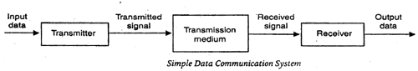
A data communication system may collect data from remote locations through data transmission circuits, and then outputs processed results to remote locations. Figure provides a broader view of data communication networks. The different data communication techniques which are presently in widespread use evolved gradually either to improve the data communication techniques already existing or to replace the same with better options and features. Then, there are data communication jargons to contend with such as baud rate, modems, routers, LAN, WAN, TCP/IP, ISDN, during the selection of communication systems. Hence, it becomes necessary to review and understand these terms and gradual development of data communication methods.
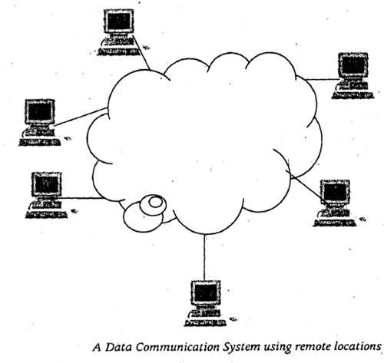
Components of data communication system

A Communication system has following components:
1. Message: It is the information or data to be communicated. It can consist of text, numbers, pictures, sound or video or any combination of these.
2. Sender: It is the device/computer that generates and sends that message.
3. Receiver: It is the device or computer that receives the message. The location of receiver computer is generally different from the sender computer. The distance between sender and receiver depends upon the types of network used in between.
4. Medium: It is the channel or physical path through which the message is carried from sender to the receiver. The medium can be wired like twisted pair wire, coaxial cable, fiber-optic cable or wireless like laser, radio waves, and microwaves.
5. Protocol: It is a set of rules that govern the communication between the devices. Both sender and receiver follow same protocols to communicate with each other.

A protocol performs the following functions:
1. Data sequencing. It refers to breaking a long message into smaller packets of fixed size. Data sequencing rules define the method of numbering packets to detect loss or duplication of packets, and to correctly identify packets, which belong to same message.
2. Data routing. Data routing defines the most efficient path between the source and destination.
3. Data formatting. Data formatting rules define which group of bits or characters within packet constitute data, control, addressing, or other information.
4. Flow control. A communication protocol also prevents a fast sender from overwhelming a slow receiver. It ensures resource sharing and protection against traffic congestion by regulating the flow of data on communication lines.
5. Error control. These rules are designed to detect errors in messages and to ensure transmission of correct messages. The most common method is to retransmit erroneous message block. In such a case, a block having error is discarded by the receiver and is retransmitted by the sender.
6. Precedence and order of transmission. These rules ensure that all the nodes get a chance to use the communication lines and other resources of the network based on the priorities assigned to them.
7. Connection establishment and termination. These rules define how connections are established, maintained and terminated when two nodes of a network want to communicate with each other.
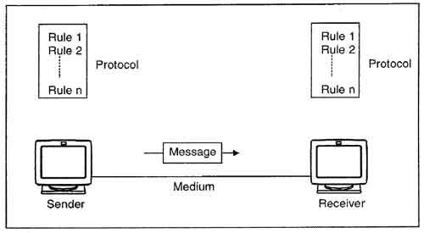
8. Data security. Providing data security and privacy is also built into most communication software packages. It prevents access of data by unauthorized users.
9. Log information. Several communication software are designed to develop log information, which consists of all jobs and data communications tasks that have taken place. Such information may be used for charging the users of the network based on their usage of the network resources.

1.2 The description differentiates between LAN's and WAN's.
Types of Networks
There are many different types of networks. However, from an end user's point
Of view there are two basic types:
Local-Area Networks (LANs)
- The computers are geographically close together (that is, in the same building).
Wide-Area Networks (WANs)
- The computers are farther apart and are connected by telephone lines or radio waves

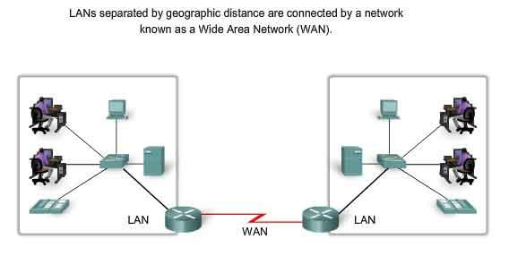

SESSION 2.
Demonstrate knowledge of main features of LANs.
Learning Outcomes
- The demonstration identifies the uses of LAN's with respect to current practice.
- The demonstration identifies the main types of LAN media.
- The demonstration describes the main LAN configurations.
- The demonstration describes LAN bandwidth.
- The demonstration describes LAN protocols.

2.3 The demonstration identifies the uses of LAN's with respect to current practice
The demonstration describes LAN protocols
Definition - A LAN is a network that is limited to an area such as a building or school.
In a LAN, computers and hardware such as printers can be connected by cable (copper wiring), fibre optic cabling (glass fibres) or using a wireless (radio waves) connection.
Protocol
The protocol defines a common set of rules and signals that computers on the network use to communicate. One of the most popular protocols for LANs is called Ethernet. Another popular LAN protocol for PCs is the IBM token-ring network.
Architecture
Networks can be broadly classified as using either peer-to-peer or client/server architecture. Computers on a network are sometimes called nodes. Computers and
devices that allocate resources for a network are called servers.
Local Area Network (LAN)
LAN is a computer network that spans a relatively small area. Most LANs are confined to a single building or group of buildings. However, one LAN can be connected to other LANS over any distance via telephone lines and radio waves. A system of LANs connected in this way is called a wide-area network (WAN).

Most LANs connect workstations and personal computers. Each node (individual computer) in a LAN has its own CPU with which it executes programs, but it is also able to access data and devices anywhere on the LAN. This means that many users can share expensive devices, such as laser printers, as well as data. Users can also use the LAN to communicate with each other, by sending e-mail or engaging in chart sessions.
There are many different types of LANs-token-ring networks, Ethernents, and ARCnets being the most common for PCs. LANs are capable of transmitting data at very fast rates, much faster than data can be transmitted over a telephone line; but the distance are limited, and there is also a limit on the number of computers that can be attached to a single LAN.

2.4 The demonstration describes the main LAN configurations
Typical LAN configurations are star,ring and bus networks.

4BUS NETWORK
A bus network is made up of a cable called a bus that is shared by all the workstations or network nodes. All the nodes receive transmitted data, but the node to which they are addressed only accepts the data. Bus networks are easily and cheaply installed. An example of a bus network is Ethernet, the most popular network.
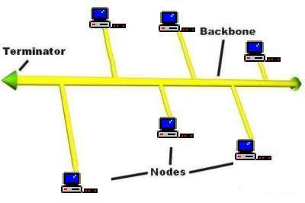
RING NETWORK
A ring topology is where workstations are connected in a ring pattern. Signals in the ring are sent in one direction from the source node, around the ring from node to node, until they reach the destination. A ring network can be designed so that a malfunctioning terminal will not cause problems for the other terminals. IBM's Token Ring is an example of a ring network.
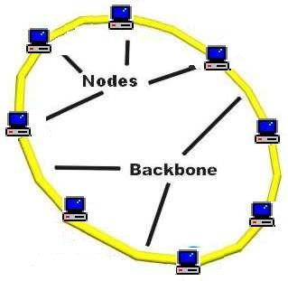
STAR NETWORK
A star network is where each workstation is connected to a central workstation called the network server. The cable is not shared in a star network. So if the server ceases to function it can cause total loss of communication on the entire network. If any one workstation is not working properly, it will not effect any other workstation. StarLAN from AT&T is an example of a star network.
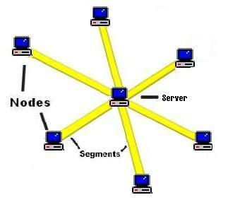

Advantages of LANs:

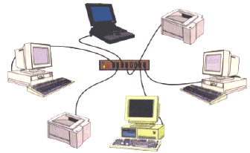
- Hardware such as printers can be shared so individual workstations do not need their own printer. When they print, the data is stored in a queue on a server. The data is then passed to the printer.
- All the users work can be stored in a central place (the dedicated file server) so a user can access their work through any computer on the network.
- Software can be shared; software packages are stored on the server and downloaded to workstations as requested. Note that a licence still has to be bought for each copy of the software needed.
- Data can be shared because database files stored in the server are available to users around the network; data from CD-ROMs can also be shared across the network.
- Central back-up can take place automatically at regular intervals. A user will usually be able to retrieve work that has been deleted by mistake.
- Messages can be sent to people working at other computers on the network which can save time and paper.
- It is possible to set up a local intranet such as that on the KLB school network. The web pages of information can be accessed only over the LAN. An intranet is free because it does not involve phone links.
- There is control over users’ access rights to programs and data.

Disadvantages of LANs:
- Printing can be slow. Where a lot of workstations are served by only one or two printers, long print queues may develop.
- A virus can spread more easily. If a virus gets into one computer, it is likely to spread quickly across the network because it will get into the central backing store.
- As data is shared there is a greater need for security. Users of the network have to have authentication techniques such as user ids and passwords. Unique user ID's control access to the files and settings on the network while passwords prevent unauthorised users from logging onto the network. Data may also have to be encrypted so that it is meaningless if intercepted.
- If the server fails, all the workstations are affected. Work stored on shared hard disk drives will not be accessible and it will not be possible to use network printers either.
- The cost of installing the equipment is greater. Cabling can be expensive to buy and to install.
- Damage to cables can isolate computers. Some sections of the network can become isolated and will not be able to communicate with the rest of the network.
- Because networks can be complicated to maintain, a network manager may be need to be employed to run the system.

2.5 The demonstration identifies the main types of LAN media
LAN media define how you access the network physically. Three common LAN media are
* Copper UTP cables (commonly referred to as Ethernet patch cables), it's the cheapest way of connecting a device to the LAN. Very commonly used for normal connections up to 1 GBit/s.
* Optical Fiber, rather expensive but allows for very high bandwidths. Thus, it's usually used as backbone cabling rather than normal connections between devices.
* Wiress LAN, which uses radio waves transmitted through the air. Slower than wired LAN but allows for greater mobility of the hosts. Security may be a bit shaky, thus it's usually not used in security sensitive environments.

2.6 The demonstration describes LAN bandwidth.

LAN Bandwidth Management
A LAN (Local Area Network) usually covers a small area such as a certain office, a few buildings, or perhaps just a home. Unlike WANs (Wide Area Networks), LANs have no need for leased telecommunication lines, and tend to have very high data transfer rates. In order for a LAN to run smoothly, the network manager needs to keep a close eye on the bandwidth usage. By monitoring it carefully and being aware of which applications use up the most bandwidth, problems such as performance bottlenecks can be avoided.PRTG Network Monitor is the ideal solution for easy, reliable LAN bandwidth management. This bandwidth measurement software provides administrators with live readings as well as long-term usage trends, all in clear, easy-to-read graphs and tables. With accurate information about network traffic and bandwidth usage, you can manage your LAN in a proactive way and steer clear of costly and time-consuming problems.

SESSION 3.
Demonstrate knowledge of main features of WANs.
Learning Outcomes
- The demonstration explains the uses of WAN's with respect to current practice.
- The demonstration explains the uses, hardware requirements and advantages of WAN's.

3.1 The demonstration explains the uses of WAN's with respect to current practice
WANs - Wide Area Networks
A WAN is a computer network that spans a relatively large geographical area. Typically, A WAN consists of two or more local-area networks (LANs).Computers connected to a wide-area network are often connected through public networks, such as the telephone system. They can also be connected through leased lines or satellites. The largest WAN in existence is the Internet
Definition - a Wide Area Network is not confined to one building. The computers and terminals forming part of the network can be spread around the world.
External communication links such as satellites, microwaves, telecommunication links and optical fibre will be used to connect the parts of a WAN. The connection must normally be paid for because the links are external. The Internet is a worldwide WAN and a LAN can be connected to it using a router.
Advantages of WANs:
- These are similar to those of LAN's except the scale of sharing etc. becomes far greater and can be world-wide.
Disadvantages of WANs:
- Again these are similar to those of LAN's except that issues such as security become even more important as potential hackers could break into a computer system from anywhere in the world rather than having to physically be in a building.
- Encryption of secure data such as financial transactions is necessary because it is even easier to intercept data.

Revision points - you should be able to do the following:
- Explain what is meant by a network and know the benefits of networking computers
- Define a LAN (Local Area Network) and a WAN (Wide Area Network) and discuss the advantages and disadvantages of each
Questions:
What is a network?
- Explain what a Wide Area Network is.
- State one advantage and one disadvantage of a WAN.
- When using a LAN, why is it necessary to have a password?
- Describe the software that makes up a network.
- Describe the devices that make up a typical network.

3.2 The demonstration explains the uses, hardware requirements and advantages of WAN's.

Important terms used in Networking
(a) Internet
The newest type of network to be used within an organisation is an internet or internet web. Such networks enable computers (or network) of any type to communicate easily. The hardware and software needs are the same as for the internet, specifically TCP/IP, server and browser software used for the World Wide Web. Because most organisations have a need for more dynamic ways to link people and information, the internet market is expanding day by day. Moreover, there is no need to adjust the network when a new user joins in. With the help of Internet, all computers of an organisation can work as stand-alone systems, connected to a mainframe, or part of a LAN or WAN.
(b) E-Mail
E-mail stands for electronic mail. This is one of the most widely used features of Internet. Mails are regularly used today where without the help of postage stamp we can transfer mails anywhere in the world. With electronic mail the service is similar. But here data is transmitted through Internet and therefore within minutes the message reaches the destination may it be anywhere in the world. Therefore the mailing system through e-mail is excessively fast and is being used widely for mail transfer.
(c) Voice Messaging
It is a new communication approach which is similar to electronic mail except that it is audio message rather than text messages that are processed. A sender speaks into a telephone rather than typing, giving the name of the recipient and the message. That sender's voice signal is then digitised and stored. The system can then either deliver the message at a specified time in future or it can be retrieved from a database by the recipient. The message is reconverted back into its analog format when it is delivered or retrieved so that the recipient hears it as the original sender's voice on a telephone. Voice messaging requires a computer with an ability to store the audio messages in digital form and then convert them back in an audio form upon verification. Each user has a voice mailbox in secondary storage and special equipment converts the audio message to and from the digital form. The main advantage of voice mail over electronic mail is that the sender does not have to type. Voice mail also makes it easy to include people in the firm's environment in an communication network.
(d) E-Commerce
Electronic commerce or e-commerce as it is popularly known refers to the paperless exchange of business information using Electronic Data Interchange, Electronic mail, Electronic Bulletin Boards, Electronic Fund Transfer and other network based technologies. Electronic Commerce (EC) not only automates manual process and paper transactions, but it also helps organisations to move into a fully electronic environment and change the way they usually operate. Few organisations have recently started conducting EC over Internet, the network of networks. Internet has also helped EC to boost up because it is a low cost alternative to the proprietary networks. EC standards are however under development. Electronic Data Interchange (EDI) is still the dominant part of EC. Information Technology has transformed the way people work. Electronic Commerce (EC) has unearthed yet another revolution which is changing the way business houses buy and sell products and services.

WAN Hardware

WAN Hardware. A WAN - Wide Area Network is a network with a much broader reach than LANs and MANs. They span across metropolitan areas and may well span across nations and language differences. The PSTN - Public Switched Telephone Network or POTS - Plain Old Telephone System is a WAN. The entire Internet is a WAN. A home user's connection to the Internet is very likely done through a WAN. While they interact with LANs, they are fundamentally different in form and functions.
The hardware required to implement a WAN link can be as simple and readily available as a modem and a telephone line. On the other hand it can be complicated and expensive, such as satellites and transoceanic cabling. This webpage will survey some of the most frequently used hardware.
Modems. The word modem originally derived from modulation/demodulation. This needs to occur in order to take digital signals from/to computers and transmit/receive them over analog telephone lines. Currently, they take on an even larger variety of basic approaches to functioning.
They tend to come in two main varieties in terms of their relative position inside or outside the transmitting/receiving device. Modems can be categorized as internal or external.
One of the main advantages of an internal modem is compactness. They are circuit boards that fit into one of two places inside a computer.
- ISA - Industry Standard Architecture slot
- PCI - Peripheral Component Interconnect slot
Since they are inside you do not need to find extra space on the desktop, nor do you need an extra serial cable.
Unfortunately, internal modems are traditionally more difficult to configure than external ones. Several things need to be set in order to ensure there aren't conflicts with other internal components.
- IRQ - Interrupt Request
  - this is an assigned location where the system expects the device, in this case a modem, to interrupt it when the device sends a signal
  - signals that go to a processor on the same line would interrupt each other
- Input/Output Address
  - this is the memory location where data from the device is stored in order to be processed by the CPU
  - again, if multiple devices try to use the same I/O address it will inevitably result in conflicts
- Virtual Com Port
  - this is a logical port number by which the operating system identifies a serial port
  - you must set each serial device to use a different com port
All modern operating systems provide a means by which you can view how resources are being used.
Modifying these settings depends on the modem. The following list gives three typical ways these settings can be changed.
- Dip switches - these are small switches directly on the circuit board that can be moved
- Jumpers - pairs of metal pins built into the circuit board that represent an electrical contact point
  - configured so that a small plug is placed on the pins to complete a circuit
- Software - a software program is used to change the configuration
Many modems support PNP - Plug and Play technology which enables the operating system to
- detect the device
- install the necessary software drivers
- detect what resources are available on the computer
- assign particular resources to the device automatically
Little or no intervention is required from the user. Unfortunately, these sorts of devices require your computer's operating system to have features that are compatible.
External modems have a couple advantages over internal ones.
- most provide status lights
  - power is on
  - connected
  - transferring data
- usually easier to configure and install than internal ones
A couple disadvantages of external modems are
- they require a power cord to plug into an electrical outlet, rather than running off the computer's power like an internal modem
- they require a serial cable to run from the modem to one of the serial ports on the back of the computer
To use an external modem you need to have an available serial port. Most computers have two built in serial ports, COM 1 and COM 2, with connectors on the back of the computer. It is important to remember that many other devices such as scanners, digital cameras and serial printing devices also use serial ports.
If your computer doesn't have a serial port then you have a few options.
- use an internal modem
- install an expansion card in your computer
- if you have a USB you can chain several serial devices off a single port
Serial ports make use of a UART - Universal Asynchronous Receiver/Transmitter chip to handle serial communications. This chip comes in different types and the type used determines how fast data can be transferred over the serial port.
Drivers are software programs that act as liaisons between hardware devices and the operating system. Some modems require a modem driver that either comes with the modem or can be downloaded from the manufacturer's website.
A computer may also be configured as a dial-up server or remote access server to allow other computers to dial into it and connect over the phone lines. Computers running particular server software can support many remote access connections simultaneously. In order to do this the server needs to have a modem bank. The modem bank allows the server to make use of a group of modems simultaneously.
ISDN and DSL Adapters. The device used to connect a computer to an ISDN - Integrated Services Digital Network or DSL - Digital Subscriber Line is often referred to as a modem. It is more accurate to call it a terminal adapter. It doesn't really modulate and/or demodulate signals because the lines are digital.
ISDN adapters also come in both internal and external varieties. They are configured similarly to modems, but typical 128 Kbps ISDN service consists of two data channels each running at 64 Kbps. The two data channels usually have separate phone numbers.
ISDN adapters are configured with information about the SPID - Service Profile Identifier for each channel. Each of these SPIDs consists of a telephone number, a two digit sharing terminal identifier and a two digit terminal identifier. Some more recent models support automated SPID selection and don't require the admin to enter the information.
DSL adapters or endpoints are required at both ends of a DSL connection. Sometimes these endpoints are external. Other times they are placed together with the NIC on the same card.
Customer Premises Equipment. CPE - Customer Premises Equipment is a general term that encompasses several different devices. These are used for processing transmissions on WAN links such as
- T-1 lines
- T-3 lines
- X.25 connections
- Frame Relay links
